Contents

I Introduction 2

II Overview Of iCog Makers’ Robo-Soccer Cup 3

III Scope of the Robots 5

1) The Original RoboSapien 5

2) iCog Makers Augmented RoboSapien 6

2.1 Specification of the augmented RoboSapiens 7

IV iCog Makers Robo-Soccer Cup: Rule of the Game 7

Rule I: Field of Play 8

Rule II: The Ball 9

Rule III: Number of players 9

Rule 4: Player’s equipment 10

Rule 5: Head referee 10

Rule 6: Match duration 10

Rule 7: Ball in and out of play 10

Rule 8: Method of scoring 11

Rule 9: Fouls and misconducts 11

Rule 10: Free kicks 11

Rule 11: Penalty kick 11

Rule 12: Goal kick 11

V) Rule of the Competition 11

1) The Award 11

2) The Schedule 11

4) The Program Codes 12

Index 13

1) The MIT License 13

How to apply this license 13

2) MOU with AAiT 13

3) MOU with AASTU 13

# I Introduction

iCog Labs aka LABS-ICOG Software Consultancy is a research and development company based in Addis Ababa, Ethiopia, collaborating with international AI research groups and serving customers around the world.

The company has helped its customers with a variety of projects, but our core specialty is artificial intelligence, including machine learning based data analysis, computational linguistics, computer vision, mobile robots and cognitive robotics, cognitive architectures and artificial general intelligence.

Our staffs bring experience contributing to international AI development teams, as well as software and hardware development experience in Ethiopia’s government and private owned industries. We are core contributors to the OpenCog open source AI platform and utilize OpenCog within our projects as appropriate.

We carry out our work in partnership with a number of international organizations including: US AI firm Novamente LLC, US bioinformatics firm Biomind LLC, Dr. Gino Yu's lab at Hong Kong Polytechnic University and the OpenCog Foundation.

We also have an agreement with 21 public universities in Ethiopia to establish a hacking center in the respective campus. Furthermore, our company is one of the major stakeholders in the soon to be launched projects of the respective Universities involved in the field of Artificial Intelligence Development within Ethiopia.

# II Overview Of iCog Makers’ Robo-Soccer Cup

In today’s world, the impact of technology is enormously loud and the education system cannot afford to exclude it. Technology infuses classrooms with the digital world. Computers, Robots, 3D printers and other hand-held-devices and gadgets are no longer alienated from the day-to-day education. Rather, these are now learning tools.

An education system enhanced by technology can greatly expand what the course at hand aims to offer. It will be industry based and the student will develop first-hand experiences on the course subject, and learning materials. In the past, education was limited to classrooms or educational field trips but now, via technology, learning can be conducted 24 hours a day and 7 days a week. Undoubtedly, today’s technology in the formal education builds 21st century skills, increases students’ engagement and motivation; and accelerates learning.

As part of its makers initiative, iCog Labs propose its first community based project called ‘**the iCog Makers Robo-soccer Competition**’. Initially, it will use a low cost humanoid robot called RoboSapien. The *RoboSapien* is a humanoid robot designed by Mark W. Tilden, and marketed by WowWee for the toy market. Yet, contestants that prefer other kind of robots are also allowed to compete in the cup if their robots match the specifications described in the next section.

iCog Makers’ Rob-Soccer Cup envisions technology as a conduit to deliver and enhance the formal curriculum taught in high-schools and universities through hacking competitions. These competitions will undoubtedly encourage creativity and technical development and the positive impact of such initiatives on has been witnessed in the developed world in the past ten years.

Through the employment of these Robots, the iCog initiative provides the perfect methodology to teach students the concepts of humanoid robots’ kinematics and dynamics. Hence, iCog Makers RoboSapian Soccer cup integrates some of the very important part of engineering concepts namely the mechanical and electronics.

Moreover, although it is given that the practical experience of these concepts is a crucial factor in the on-going mainstream education, it has always been resource intensive in countries like Ethiopia. The initiative from iCog overcomes this diminishing lack of resource via the RoboSapien hacking competition. The initiative will provide staffs whose expertise is noted in the fields of robotics and as well, it grants the robots in affordable price.

Although the major aim of the competition is to empower Ethiopian universities in a way that their students can entertain a first-hand experience regarding their classroom lectures, it is not limited to university students. It is open for individuals from all walks of life, who are interested in robotics, computer programing, and electrical and mechanical engineering.

The application of such competitions has a certain positive aftermath in education and it really matters when it comes to maintain a good rate of improvement in the fields of Engineering (Electrical, mechanical, and computer).

Experiments on Humanoid Robots have credited exponential progress in the applications of creating *Industrial Robots*, which are flexible enough for unmodified environments. It creates a chance to explore new robotics applications in the least-charted areas like service, household helper, and entertainment that can generate a billion dollar industry over the global market. Interaction with people is needed, humanoid robots are the one to deliver the demand, furthermore Human-like body helps when acting in environments designed for humans and this could be applied in several sectors of African industries.

In addition to this, there is a massive potential to tap Artificial Intelligence research and development works through humanoid Robots. Furthermore, the application of the actual robots strengthens researches on Embodiment; intelligence needs body and there is an entire branch dedicated to the study of the relationship between an intelligent entity, its body, and its interaction with its environment aka Embodiment. Humanoid robots can be used as a benchmark in this field and iCog Makers Robo-Soccer Cup has the potential to exploit this field.

On the other hand, such competitions have also a community outreaching nature. The iCog Makers Robo-Soccer Cup is also going to be used to build a Future Technology community in Ethiopia. This will create an environment where local researchers, engineers and entrepreneurs give talks and lead discussions on future-technology ideas and initiatives that will reshape and complement the future of the country’s development directions.

The initiative anticipates it will be possible to recruit some of leading international scientists, engineers and entrepreneurs to serve on the Advisory Board of the iCog Makers, thus lending the competition an element of prestige, as well as a valuable source of connections and advice.

As part of the initiative iCog Labs in collaboration with its stakeholders (higher institutes and over sea companies) aim to incubate the successful projects and enable the winning contestants to create and grow their inventions into young businesses and beyond.

Once suitable infrastructure has been made available, iCog Makers initiative will aggressively recruit other universities and high schools to be part of this project as hosts, stakeholders, and contestants. The focus will be on hacking and designing humanoid robots, incubating start-ups, and facilitating research projects aimed at using humanoid robots to advance Ethiopia.

# III Scope of the Robots

## 1) The Original RoboSapien

The RoboSapien is a toy robot designed by Mark W. Tilden and it follows the principles of BEAMrobotics. Along with its low centre gravity, it has two large robot feet that maintain its balance that gives it a tenable steadiness while walking compared to other bipedal robots.

The robot’s power supply— four mono (D) type batteries— is located in its feet. It is capable of walking motions, grasping objects with its hands and throwing them mildly. It also has a small loudspeaker unit, which can broadcast several different vocalizations.

It is possible to let the robot walk forward or backward with two different speeds and to let it turns on the spot. It can raise and lower it arms as well as twisting them. The robot has nine degrees of freedom that are driven by seven motors.

One motor in each leg moves two joints in the hip and the ankle, keeping the foot mutually in perpendicular axes at right angles (orthogonal) to the trunk. A trunk motor tilts the upper body to the left and right. One motor in each shoulder raises and lowers the arm and one motor in each elbow twists the lower arm. Its gripper hands are consisted of three fingers each. One has to twist the lower arm outwards to open its gripper while twisting it inwards closes the gripper again.

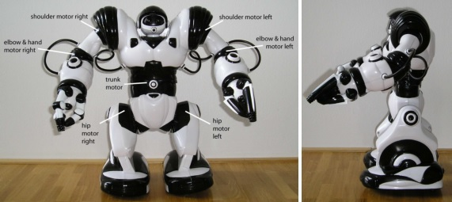

1. The Original RoboSapian and the motors locations are seen here. Its trunk motor tilts the upper body to the right. The centre of mass shifts over the right foot and then the left foot lifts from the ground.

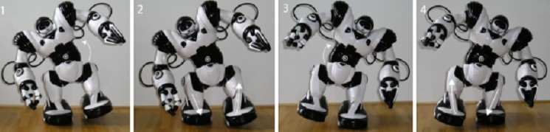

2 The leg motors move into opposite directions, resulting in a forward motion then the leg motors move into opposite directions, resulting in a forward motion of the robot. As the upper body swings back, the left foot regains contact with the ground.

The robot, originally, is designed to be controlled by a user that pushes buttons on a remote control unit. It is pre-programmed with moves controlled by an infrared remote control. The remote control unit has 21 different buttons. With the help of two shift buttons, 67 different robot-executable commands are accessible. Being equipped with a basic level of programmability, the users can string together movement commands to form macros or mini-programs (instructions sets), broadcasting them to the robots via infrared.

## 2) iCog Makers Augmented RoboSapien

There are so many possibilities of hacking the original RoboSapien. Modifications like a live wireless video camera, speech synthesis, radio frequency control, integration of new controlling pocket pc (smartphones), and motion tracking CMUCam are the most common cases among others.

In iCog Makers RoboSapian Soccer completion, teams can hack the robot in way they like and there is no restraining border to limit their modification desire. They can enhance the hardware parts and as well, the software as long as the material cost applied in the process is no more than 300 USD.

When it comes to the communication of the augmented robots in the competition, teams had two options; a) the robots can communicate with each other by pocket pc (tablets, smartphones etc) or b) they can use an external computer via wireless LAN.

Hackers are expected to enhance the original RoboSapiens software and hardware component in the areas of visual perception, self-localization, behaviour control, and communication.

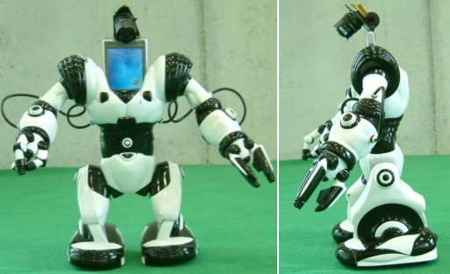

3. Augmented RoboSapiens seen here with a Pocket PC (smart phone) and CF camera. Images captured from the CF camera are analysed to detect objects of interest, such as the ball, the goals, and other players. The Pocket PC controls and decides where and how to move the robot. The motion commands are sent from the Pocket PC to the robot via a learning remote program and the Pocket PC's infrared interface. The robots can communicate with each other and with an external computer via wireless LAN or Bluetooth.

The augmented robots in the iCog Maker’s Robo-Soccer Cup must have a human-like body plan. They must consist of a trunk, two legs, two arms, and a head. The only allowed mode of locomotion is bipedal walking. The robots must be fully autonomous— no external remote control operated by humans is allowed.

### 2.1 Specification of the augmented RoboSapiens

* The weight of the augmented robots should not exceed 4 kg and the height must be under 45cm.
* The robots, under any circumstance, cannot use a human interaction via a remote control or a computer operated by humans during the match time.
* The robots are not allowed to compete if their movement is alter in any way other than the universal bipedal movements of humans. Teams can increase the speed of their robots’ stride or they can add a future like jumping but it must always be a robot walking on two legs; gliding, quadrupedalism, and flying is not permitted.
* Each robot’s foot, at least, must fit into a 6cm2 but not exceeding a 24cm2.

# IV iCog Makers Robo-Soccer Cup: Rule of the Game

Although the final objective of iCog Maker’s Robo-Soccer Cup is to create autonomous humanoid robot soccer players that can play in accordance with FIFA’s rules and regulation, for the time being it will be restricted to the following rules and regulation regarding field size, number of players, and modified rules of the soccer game. Essentially, all the rules are adopted from FIFA’s Soccer rule with minor modifications with the exception of major rules like Throw-in, Corner Kicks, and Offside that are totally discarded.

## Rule I: Field of Play

The field of play is between 3.2 meters long and 2.6 meters wide. The goals are 90cm wide and 30cm high while they will be 27 cm deep. Instead of nets, coloured box will be attached to the goal posts. The ﬁeld of play is divided into two halves by a halfway line measuring 1.6 meters long and 2.6 meters wide.

The centre mark is indicated at the midpoint of the halfway line and a circle with a radius of 45 cm is marked around it. The goal area will also follow the marking styles of FIFA except that of the lines’ length. Two lines are drawn at right angles to the goal line, 15cm from the inside of each goalpost. A 21cm line drawn from the goal line will be joined by the line of the penalty box at the right angles hence the penalty box will be 1.62m of width and 57cm of length.

In the first stage of the iCog Maker’s Robo-Soccer Cup, there will be no corner kicks and hence there will be no marking for the corner arc circle.

The following areas of the football field will be marked: touchlines/side-lines, goal lines & goal areas, halfway line, centre circle, penalty areas, arcs and spots, and corner arcs.

The colour of the field will be green and the marking lines will be white. To enhance the visibility of these lines (as seen by the autonomous robots and their vision analysis and localization system), there width will be 2-3cm. Each goal boxes will be marked with different colours along with six markers on the edge of the filed which will be used as colour markers for localization. The Specific RGB of the markers is as follows:

* For the Goal Posts (Purple RGB: #FF00FF, (255, 0, 255) and Turquoise RGB #00FFFF, (0, 255,255)
* For the additional two colours in the Markers (Yellow RGB: #FFFF00, (255,255, 0) and White RGB: #FFFFFF, (255, 255, 255).

One can see the details of the field and the markers in the following image.

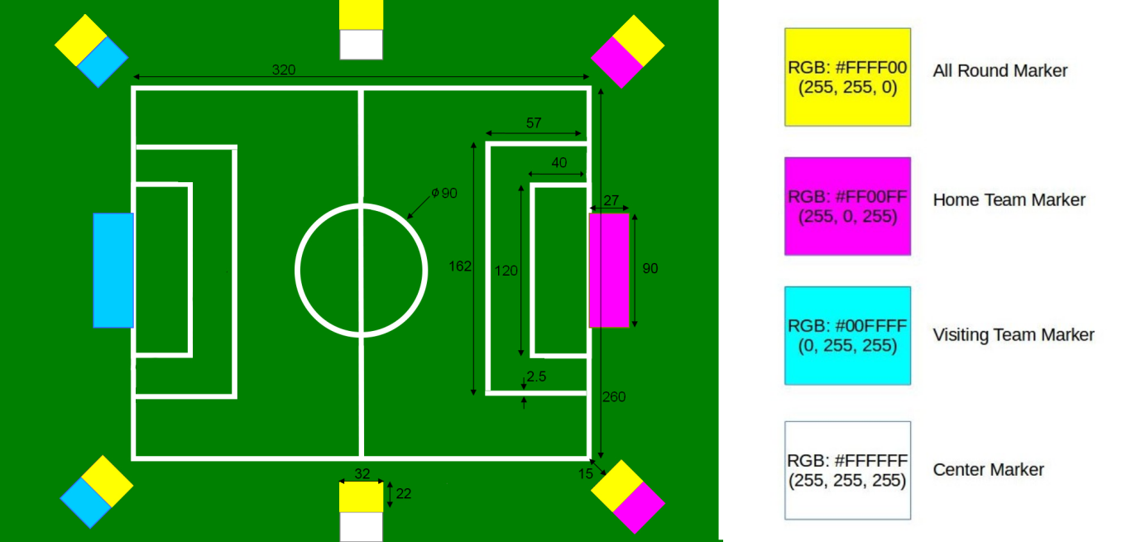

4. iCog Makers Robo-Soccer Cup playing field

## Rule II: The Ball

The soccer ball’s diameter will be 2.2 to 3.2cm and must weigh no more than 250 grams. For the robots to track the ball, its colour will always be Red with an RGB value of #FF0000 (255, 0, 0). If it bursts while in play, the game is stopped and resumed by the referee dropping the ball between two players from opposing sides.

## Rule III: Number of players

A football match is played by two teams of no more than three players each, with one player per side playing a goalkeeper. The minimum number of players in a soccer team is two. (If teams lost a robot due to malfunctioning or other unexpected coincidences)

A match is not started or continued if there are less than two robot players in a team and the team that couldn’t keep up with the minimum number of robot players will lose match point in a forfeit.

There is no limit to the number of substitutions and there can be as many as three or unlimited substitutions, depending on what each side have pre-registered as player robots before the beginning of the match.

## Rule 4: Player’s equipment

The augmented Robots must satisfy the specification limit described in section III of this paper. Contestant teams can colour their player robots in their own accord with the exception of these five colours: Green, Yellow, Blue (Turquoise), Purple, and Red. Yet, teams can use these five colours in a lesser significant portion in (in a less than 4x4 cm square) in case of displaying logo and emblem on the body of the robots.

## Rule 5: Head referee

For iCog Makers Robo-Soccer Cup, there will only be one human referee. The referee will be authorised to ensure that:

a) Player robots does not violate the specification of the competitions augmentation rule

b) The robots are autonomous and no human interaction is happening during the match

c) Signalling the start and end of game

d) Citing and punishing violations of rules, and hand a penalty or free kick against the offender

e) Stopping play if a player robot is malfunctioning and requires a quick software reboot or hardware replacement and such time should not exceed 5 minutes

f) Placing the robots into their respective halves when the ball is out of play and on the rare occasion, if a robot falls down, picking that up

g) Untangling the robots if two or more robots are blocking each other's movement and vision for a duration longer than 1 minute

The referee cites fouls and infringement of the rules and prevents repeated occurrences of unsportsmanlike conduct by cautioning players with a yellow card or sending them off with a red card. Two yellow cards in football is equivalent to a red card. A player who receives a red card in football cannot be replaced so his team must continue the game with one man less.

## Rule 6: Match duration

The match will have the length of 22 minutes played in two equal halves of 11 minutes. There will be some additional minutes at the end of the match to compensate times lost during the match time regarding robots’ malfunction and the time it takes to reboot them.

## Rule 7: Ball in and out of play

The soccer ball is out of bounds when it has crossed the goal line on each side of the Goal whether on the ground or in air. If the ball goes over the left and right side of the field’s touchlines, the game will not be restarted by the traditional throw-in. Hence, the first phase of iCog Makers Robo-Soccer Cup will not apply the rule of throw-in as the matches are going to be conducted in a side closed football field.

## Rule 8: Method of scoring

A goal is scored in football if the ball crosses the goal line between the two goalposts and under the crossbar, as long as no violation of the rules has taken place. The side that scores the most goals wins. If both teams have the same number of goals at the end of the match or if neither of them scored a goal, it is considered a draw.

## Rule 9: Fouls and misconducts

The following are the [most common fouls in football](http://www.football-bible.com/soccer-info/soccer-foul-rules-misconduct-explained.html): kicking, tripping, pushing, or charging another player recklessly; striking or attempting to strike an opponent or any member of the opposing side. A foul is called if a player Robot commits one of this conducts.

## Rule 10: Free kicks

A [free-kick in football](http://www.football-bible.com/soccer-info/soccer-free-kick-rules.html) restarts a play after a foul or rule infringement is committed and is usually taken from the spot where the violation was committed. A free-kick can either be “direct”, in which a kicker may score directly, or “indirect”, in which another player must touch the ball before a goal can be scored.

## Rule 11: Penalty kick

If a defender robot commits a foul inside his own penalty area, a [penalty kick](http://www.football-bible.com/soccer-info/soccer-penalty-kick.html) is awarded. The kick is taken from the penalty spot and all the robots (except the kicker and the goalkeeper) must be outside the penalty area and penalty arc.

## Rule 12: Goal kick

A goal-kick in football is awarded to the defending team if the opposing team causes the ball to go over the goal-line. Any player from the defending side is allowed to take the goal kick. It must be taken anywhere on the goal area and must go beyond the penalty area or it will be retaken. The ball must be touched by another player before the taker can play it again.

# V) Rule of the Competition

Since the aim of this competition focuses on the spread of knowledge, there are certain regulations regarding the codes, the augmented robots, and related matters. The competition will also offer award prizes for top three teams the prize money will increase every year.

## 1) The Award

iCog Labs will grant an award of 25,000, 15,000 and 7,000 Ethiopian Birr for the top three teams at the end of the robo-soccer cup.

## 2) The Schedule

After the final day of registration for competing teams is announced, which will be announced on iCog Makers Website at the beginning of every year’s robo-soccer cup, teams will have three months (120 days) to complete their hacking projects. By the end of the third month, the grouping procedure will take place either in iCog Labs head office or in one of its office inside Addis Ababa Institute of technology. And all the first pairing of teams will be determined by means of a draw.

Every match fixture will then be announced on the iCog makers’ website. Depending on the number of competing teams, the initiative will either arrange the matches as knockout or group stages.

a) If matches are played according to the knockout system, each team will play each opponent twice, in home and away matches. The team which scores the greater aggregate of goals in the two matches qualifies for the next stage. And pairing of teams for the second round will be determined by a means of draw will determine. The stage will continue like this until there is left the final four.

b) If matches are played in **Group stage** teams are drawn into eight or four groups of four. (the number of the groups depend on the number of registered teams) Each team plays against each other in its group. Three points are awarded for a win, one point for a draw, and none for a defeat. If two or more teams are equal on points on completion of the group matches, the following criteria are applied to determine the rankings

* higher number of points obtained in the group matches played among the teams in question
* superior goal difference from the group matches played among the teams in question
* higher number of goals scored in the group matches played among the teams in question

**3) Broadcast and Coverage**

Matches will be broadcasted live stream in the iCog Makers website. They will also get the media coverage from any interested media outlet and there is no restriction on the broadcasting and coverage of the iCog Makers Robo-Soccer Cup matches.

Depending on the situation, the final match of each season’s final competition matches will be held either in the Head office of The Federal Ethiopian Ministry of Science and Technology or in public places like Meskel Square or Millennium Hall in Addis Ababa.

## 4) The Program Codes

Winning teams at the end of the cup will submit their codes to iCog Labs and it will be released for the public via iCog Maker’s website under the MIT Licence. The [MIT License](http://choosealicense.com/licenses/apache-2.0/) is a permissive license, which lets people do anything they want with the code as long as they provide attribution back to the team and don’t hold the team liable. (See Index)

Each year, new teams will be educated the basics of such programing and the top three winning teams’ code might be used as a teaching material depending on the situation

If there is a possibility to commercialise the code, Teams have full autonomous right to rip the financial benefits of such deals.

# Index

Here is the document teams are going to use for the license with a simple explanation of how to use it along with several MOU arguments with iCog’s partner Universities.

## 1) The MIT License

Since the top three program codes of the soccer competition are going to be Public repositories on iCog Makers Website, in the aim of sharing it as an open source software with all the rest Ethiopian, it has chosen to use the MIT License as its open source licensing method.

Here is the license and users can follow the guide below the license when they file their codes to iCog makers repository.

The MIT License (MIT)

Copyright (c) [year] [fullname]

Permission is hereby granted, free of charge, to any person obtaining a copy of this software and associated documentation files (the "Software"),to deal in the Software without restriction, including without limitation the rights to use, copy, modify, merge, publish, distribute, sublicense, and/or sell copies of the Software, and to permit persons to whom the Software is furnished to do so, subject to the following conditions:

The above copyright notice and this permission notice shall be included in all copies or substantial portions of the Software.

THE SOFTWARE IS PROVIDED "AS IS", WITHOUT WARRANTY OF ANY KIND, EXPRESS OR IMPLIED, INCLUDING BUT NOT LIMITED TO THE WARRANTIES OF MERCHANTABILITY, FITNESS FOR A PARTICULAR PURPOSE AND NONINFRINGEMENT. IN NO EVENT SHALL THE AUTHORS OR COPYRIGHT HOLDERS BE LIABLE FOR ANY CLAIM, DAMAGES OR OTHER LIABILITY, WHETHER IN AN ACTION OF CONTRACT, TORT OR OTHERWISE, ARISING FROM,OUT OF OR IN CONNECTION WITH THE SOFTWARE OR THE USE OR OTHER DEALINGS IN THE SOFTWARE.

### 1.1) How to apply this license

Create a text file (typically named LICENSE or LICENSE.txt) in the root of your source code and copy the text of the license into the file. Replace [year] with the current year and [full name] with the name (or names) of the copyright holders or the Team Name.